Exam 4 Basic lecture outline
Check page breaks before printing

IX. Plant Biology

A. Reproduction (life cycles)
1. all
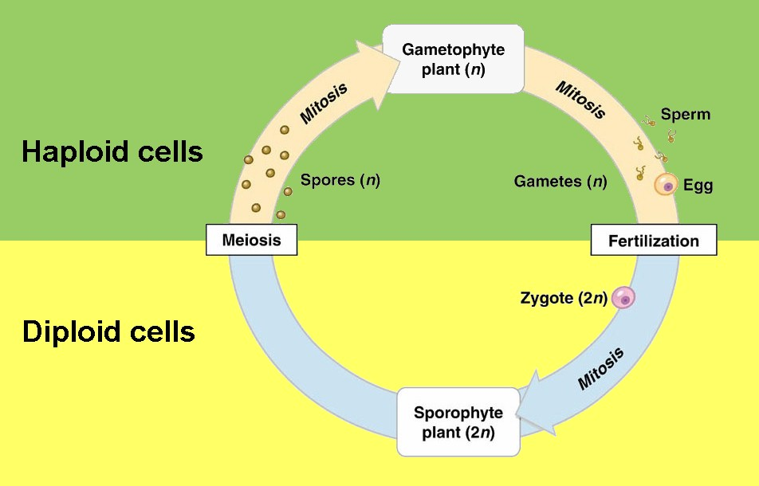

a.
b.
c.
d.
2. bryophytes’ version of alternation of generations
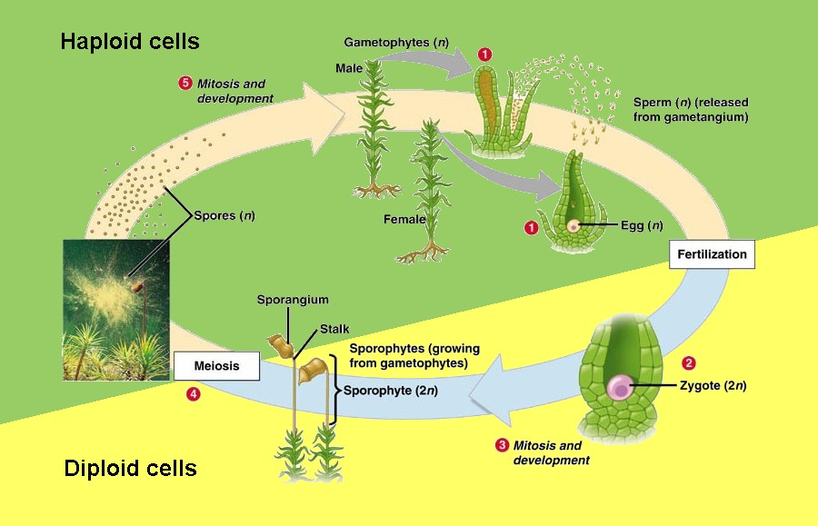

a.
b.
c.
3. ferns’ version of alternation of generations (and all other
lower vascular plants too)
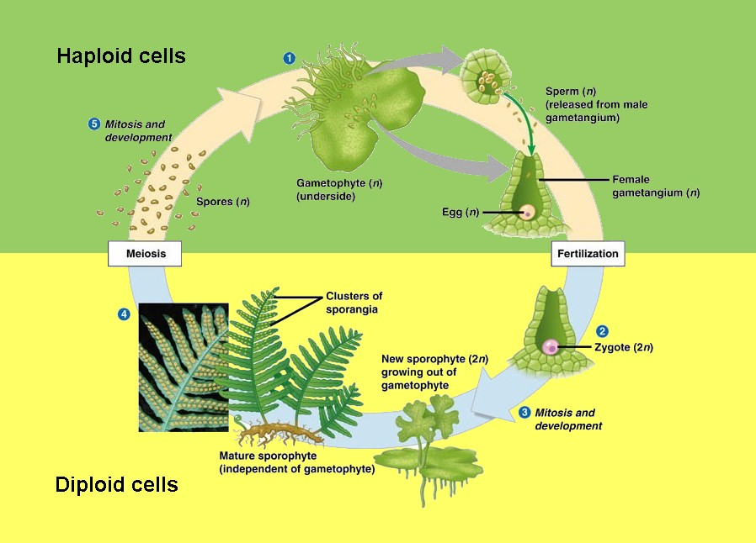

a.
b.

c.
4. flowering plants’ version of alternation of generations
(flowering plants are angiosperms)

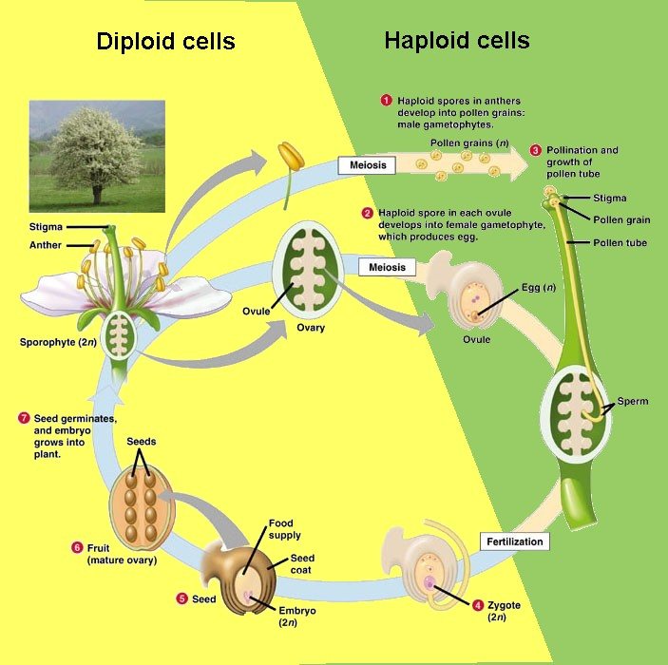

a.
b. gametophyte is
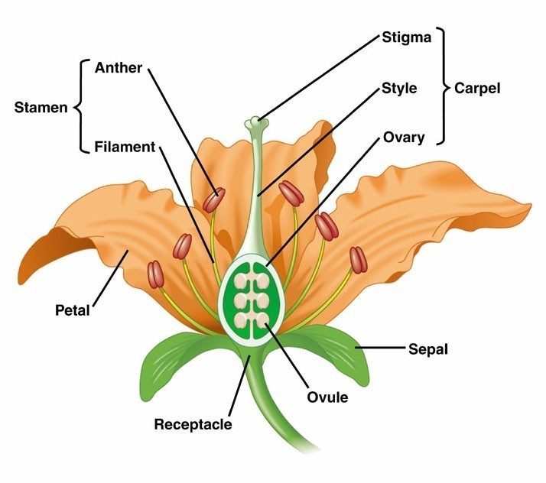

1) totally dependent on
2) makes gametes
(the seed is

c.
5. summary
 | Mosses | Ferns | Flowering plants
Sporophyte  (always 2n) | parasitic | photosynthetic  dominant | photosynthetic  dominant
Gametophyte  (always 1n) | photosynthetic  dominant | photosynthetic | parasitic  inside flower

B. Pollenation: flower structure matches pollenator
1. wind-pollenated plants
a.
b.
c.
2. butterfly-pollenated plants
a.
b.
c.
3. moth-pollenated plants
a.
b.
c.
d.
4. bee-pollenated plants
a.
b.
c.
d.
5. fly-pollenated plants
a.
b.
6. beetle-pollenated plants
a.
b.
c.
7.
a.
b.
c.
8. bat-pollenated plants
a.
b.
c.

9. summary
Pollenator | Flowers | Nectar tube | Scent | Other
Wind | small drab | none | none | lots of pollen
Butterflies | red or blue | long curved | little | open 24 hours/day
Moths | pale | long curved | strong sweet | open at night
Bees | yellow or  blue | short | sweet | infrared patterns
Flies | small drab | short | stinky | ---
Beetles | pale | moderate | fruity or spicy | ---
Hummingbirds | large red | long (straight) | little | bill shape matches  flower shape
Bats | large pale | moderate | strong sweet  or fruity | stems strong or  hanging

C. Hormones
1. auxin
a.
1) bending cued
2) auxin more concentrated
b. phototropism
1)
2)
3)
c. apical dominance
1) stem tip produces auxin
2)
3)
4) e.g. avocado vs. bushes
2. gibberelins
a.
b.

3. ethylene
a.
b.

D. Plant anatomy
1. stem
a. apical meristems (buds) make new cells (mitosis)
b. pith for support
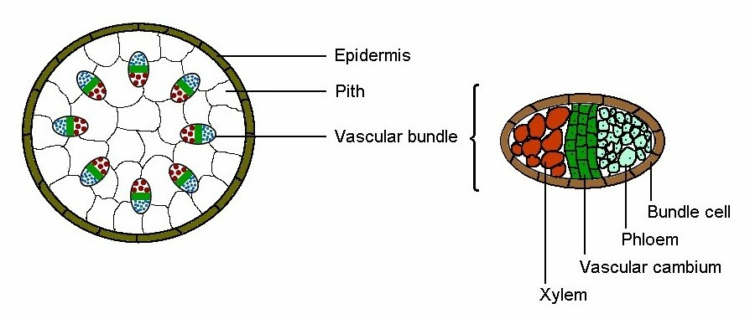

c. vascular bundles
1)
2) vascular cambium
a)
b)
3) xylem
a)
b)
c) water is a
(1)
(2)
(3) tallest tree = coastal redwood named Hyperion:
4) phloem
a)
b)
c) transports
d) mechanism unknown
e)
d. woody stems
1)
2)
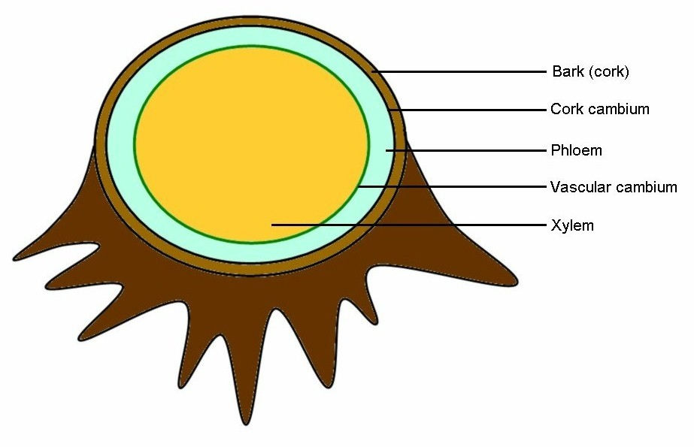

3) external bark
4) rings are
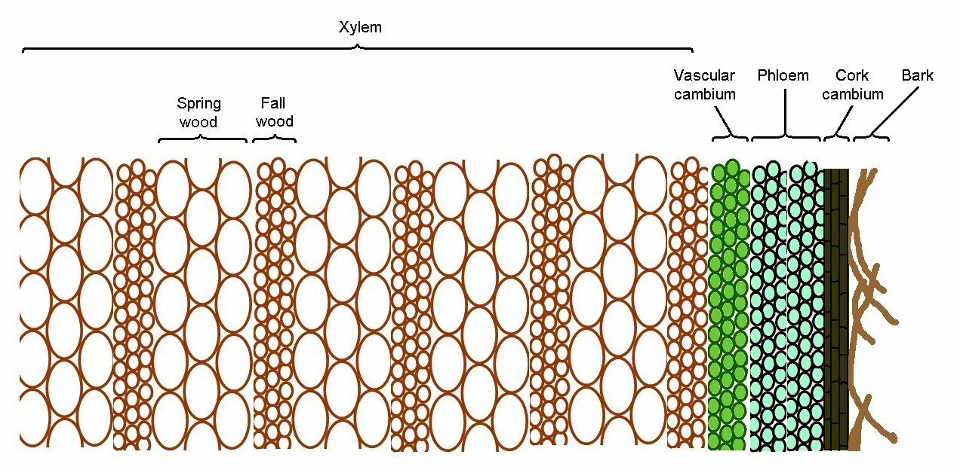

2. roots
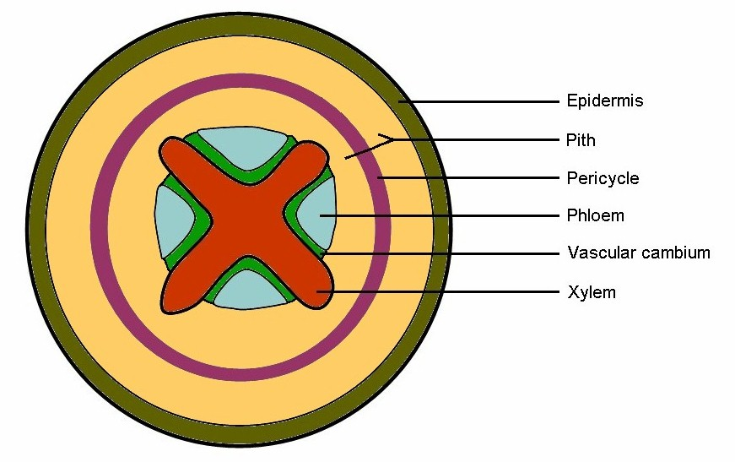
a.
b.
c.

d.
3. leaves
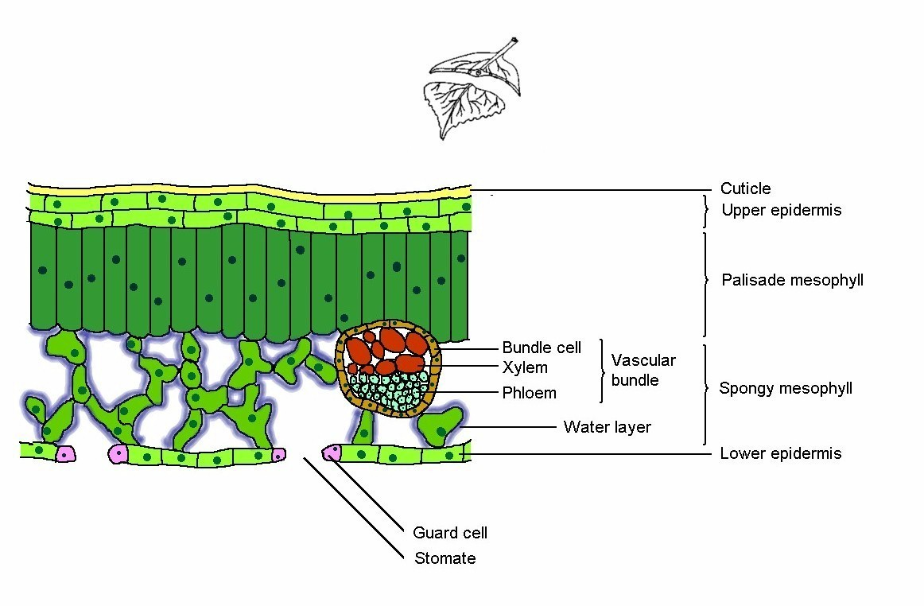

a. cuticle
1) waxy
2)
b. upper epidermis: top "skin" layer
c. mesophyll
1) palisade
2) spongy
a) provides
b)
c) most efficient way
(1)
(2)
d. lower epidermis
1) lower “skin”
2) with
a)
b) guard cells
(1) lots of water:
(2) little water:
e. vessels
1)
2)
3)

E. Photosynthesis (remember, plants respire too!)
1.
2. uses light
a. visible light: 380 to 750 nm
V I B G Y O R
400 430 480 530 580 600 700 nm
b. action spectrum =

3. light-dependent reactions
a. converts sunlight to bonds in ATP & NADPH
H₂O O₂
ADP & P → ATP
NADP NADPH

b.
4. light-independent reactions
a. Calvin cycle or "dark" reactions
CO₂ sugar
ATP → ADP & P
NADP H NADP

b. don't need light, just the products of the light reactions
c. convert energy in ATP and NADPH to a more stable form
5. photosynthesis summary

H₂O O₂
CO₂ C₆H₁₂O₆
light energy
X. Diversity

A. Viruses
1. some biologists consider them to be alive
2. not classified into classes, etc:
3. structure
a.
b.
4. life cycle
a.
b.
1) "normal" viruses (DNA):
a)
b)
2) retroviruses (RNA)
a)
b)

c)
d)
e) e.g. HIV

B. Domain Bacteria (= D. Eubacteria)
1. are prokaryotes
a.
b.
2. structure
a. cell wall
b.
c.
d.
e.
3. reproduction
a. most cells are made by
b. sex:
4. diversity
a.
b.
c. “true bacteria”
1)
2)

3)
d. Division Cyanobacteria
1)
2)
3)
a) N needed for plants:
b) N ≡ N only broken by

c) N₂ "fixed"

C. Domain Archaea ( = Domain Archebacteria)
1. are prokaryotes
2. but are very different from Bacteria
a. different
b. different
c. rRNA
d. DNA
3. found mainly in extreme environments
4. diversity
a. four divisions are
(example: geysers)
b. another division includes
1) halophiles: found in
2) methanogens:
5. summary of Domains

Character | D. Bacteria  (prokaryotic) | D. Archaea  (eukaryotic) | D. Eukarya  (eukaryotic)
Cell size | 1-10 μm | 1-10 μm | 5-100 μm
Cell wall | yes | yes | some
Internal membranes | never | never | always
Chromosomes | single, circular | single, circular | multiple, linear
Histones | never | some | always
Chlorophyll | dissolved | dissolved | on membranes
Chloroplasts | never | never | some
Mitochondria | never | never | always
Flagella | 9+0 | variable | 9+2
Ribosomes | small simple | variable | large complex

D. Domain Eukarya (Eukaryota)
1. Kingdom Protista
a. are miscellaneous eukaryotes, unicells & colonies
b. "algae"
1) life cycle
a) most cells produced
b) sex has been observed in most species:

c) alternation of generations
(1)
(2) alternating generations often look different
2) diversity (27,000 species)
a) six divisions based on
b) Division Chlorophyta (green algae)
Spirogyra, Chara
c) Division Bacillariophyta (diatoms)
Aulacoseira, Navicula
3) importance
a) oxygen production:
b) food:
(1) base of aquatic food chains
(2) human consumption: kelp, ice cream, jello
c) medicines
d) other
c. "protozoa"
1) heterotrophic (non-photosynthetic), mostly unicells
2) reproduction:
3) diversity (28,000 species)
a) eleven phyla based on
b) Phylum Ciliophora (cilates): Paramecium
c) Phylum Rhizopoda (amoebas): Amoeba
4) importance
a) most are
b) diseases: malaria, yellow fever, cholera
d. "slime molds" (580 species)
1) two divisions
2) usually
3) some are
4) some species
a) e.g. dry or cold
b) then produce
c) spores survive
2. Kingdom Fungi
a. once classified with K. Plantae, but
1)
2) cell walls with
b. most with sex
c. some are symbiotic:
1) fungus gets
2) alga gets
3) these are
d. diversity (82,000 species)
1) five divisions
2) true molds, yeasts & morels, mushrooms,
athlete's foot & Penicillium, aquatic molds
e. importance
1)
2) help most trees asorb
3. Kingdom Plantae
a. general
1) virtually all are
2) all alternate generations
a) one haploid (gametophyte), one diploid (sporophyte)
b) always look different
b. "nonvascular plants"
1) no true vessels
2) gametophyte is
3) one division: D. Bryophyta (16,000 species)
4)
c. "lower vascular plants"
1) low-growing
2) Division Lycophyta (1200 species):
3) Division Monilophyta (13,000 species):
d. "gymnosperms"
1) nonflowering vascular plants (tracheophytes)
2) diversity
a) D. Ginkgophyta
(1) only Ginkgo biloba
(2) entire
b) D. Coniferophyta (550 species): conifers
(1) wind pollenated
(2) life cycle similar to angiosperms, but
(3) includes firs, pines, cedars, redwoods, cypress
e. "angiosperms"
1) the flowering plants
2) Division Anthophyta only (235,000 species)
a) C. Monocotyledones (65,000 species):
(1) leaves with
(2) petals in
(3) includes grass, palm, lily, orchid, etc.
b) C. Dicotyledones (170,000 species):
(1) leaves with
(2) petals in
(3) includes oaks, pecans, herbs, poison ivy, etc.
4. Kingdom Animalia
a. general
1) all are multicellular (except one species)
2)
3)
b. Phylum Porifera (sponges. 5000 spp.)
1) colonial
2)
3) six cell types
c. Phylum Cnidaria (9000 species)
1) colony of interdependent cells
2) specialized cells
3)
4) includes jellyfish, corals, anemones
d. Phylum Nematoda (10,000 species)
1) roundworms
2) complete
3) protective
4) mostly predators, some parasites
e. Phylum Platyhelminthes (13,000 species)
1) flatworms
2)
f. Phylum Annelida (12,000 species)
1)
2) polychaetes, leeches, oligochaetes (earthworm)
g. other “worms” (500,000 species): 13 phyla, mostly deep sea
h. Phylum Mollusca (47,000 species)
1)
2) mostly marine
3) snails, clams, cephalpods (octopus), etc.
i. Phylum Rotifera (1800 species):
j. Phyum Arthropoda (850,000 species)
1)
2) C. Arachnida:
3) C. Crustacea:
4) C. Merostomata (4 species)
horseshoe crabs: Limulus polyphemus
5) C. Insecta (750,000 species)
insects:
k. Phylum Echinodermata (6000 species)
1)
2) initial development like chordates
3) urchins, starfish, sand dollars
l. Phylum Chordata: chordates
1)
2) “lower chordates” (1300 species): barrel-like
3) sP. Vertebrata (41,700 species)
a) “fish” (20,000 species in 3 classes):

b) Class Amphibia (2500 species)
(1)
(2) frogs, salamanders
c) Class Reptilia (6000 species)
(1)
(2) lizards, snakes, turtles, crocodiles
d) Class Aves (8600 species)
(1)
(2) birds
e) Class Mammalia (4500 species)
(1) Subclass Prototheria (3 species)
(a)
(b)
(c) platypus, spiny anteaters
(2) Subclass Metatheria (260 species)
(a)
(b)
(c) opossum, kangaroos, wallabys, etc
(3) Subclass Eutheria (4240 species)
(a)
(b) “higher mammals”
(c) sixteen orders:
bats, moles, lemurs, rabbits, carnivores,
anteaters, rodents, deer & cows, horses,
elephants, manatees, cetaceans, primates.
XI. Environmental Biology

A. Atmospheric issues
1. urban air pollution
a. from
b. mainly
c. general symptoms:
d. cleaning = prevention
1) particulates:
2) chemicals:
2. indoor air
a. radon (carcinogen)
1) decays to
2) common in granitic areas
3) here, about average
b. fireplaces
1)
2) heavy metals: from wrapping paper, comics
3) paint fumes
c. bathroom cleaners
d. much worse due to
3. stratospheric ozone
a. absorbs
b. destroyed by
c. only two-thirds of
d. predictions (as of 2010)
1) 900,000 more nonfatal cancer per year
2)
3) $2 billion damage to crops, plastics, etc
e. Antarctic ozone hole is
4. acidic precipitation
a. components
1) SO_{x} (sulfuric acid): from low-grade
2) NO_{x} (nitric acid):
b. effects
1) weakens
2) in waters,
3) in cities
a) damages car finish
b)
5. climate change (global warming)
a. greenhouse gasses:
b. natural greenhouse effect: sunlight warms Earth,
atmosphere retains some heat
c. humans: cars (50%), industry (45%), fires (5%)
d. trends
1) CO₂ concentration was
2) 2019 average:
3) 2019 maximum: 414.7
4) rising by 3 ppm/yr
e. effects
1) 25 ppm means +1^{O}F here, 2-3^{O}F at poles
2) since 1750,
3) sea level rise
a) IPCC expects
b) will be complicated by
(1) Alaskan glaciers:
(2) Greenland glaciers:
(3) Antarctica:
(4) may not be
c) threatens

d)
4) more & stronger
5) shifting
6. tropical deforestation
a. rates
1) at least 2700 square miles per year, perhaps 5000 ?
2) at least of original rainforest area
3) all of Missouri in
4) well over half gone now
b. reasons
1) huge debt of nation: sell permits to harvest wood
2) overpopulation: need cropland, but
a) crops fail after 3 years
b) pasture fails after 5 years
3) fuel gathering
c. results
1) massive
2) enhanced
3) loss of
a) 50% of all species in 3% of Earth's land area
b) potential food
(1)
(2) e.g. corn, potato
c) potential medicines
(1)
(2) HIV, cancer cures ?
d) global
e)
d. solutions
1)
2)
3)
4) enhance
5) use

B. Water issues
1. wastewater pollution (sewage)
a.
b. wastewater treatment plants:
c. feedlot sewage:
2. other pollutants
a. industrial:
b. land runoff:
c. shipping:
3. water use:

C. Solid waste
1. domestic
a) 4.5 lbs/person/day (for 2005)
b) mainly paper
8% each glass, wood, metals, plastics
2. litter
a. why:
b. control
1) more bins
2) enforcement
3)
3. negatives of solid waste:

4. waste reduction
a. reduce:
b. re-use:
c. re-cycling
1) re-production of
2) saves
3) cost is
4) paper: 1 ton = 17 trees
5) process:
d. re-formation
1) one product made from a
2) e.g. plastics
a) re-formed into
b) can't re-form for food:
c) sorted by code (7 types)
5. disposal
a. composting: pile organics, let bacteria decompose
b. incineration
1)
2) expensive
c. sanitary landfills
1) residue from all of above, plus more
2)
3) problems:

D. Hazardous materials
1. radioactive
a. sources:
b. causes
2. heavy metals
a.
b. especially paints, industrial waste
c. affect
3. toxins (toxic waste)
a. dioxins
1) industrial bleaches
2) fat soluble:
3)
b. pesticides
1) aim: complete eradication
2) problems
a) resistance:

b) biological
c)
d)
3) alternatives: aim is minimize damage
a) release
b) release
c) pheromones
d)
4. management of hazardous materials
a. cradle-to-grave tracking
b. minimize use
c. legal disposal methods
1)
2) bury in
3)
d. theoretical disposal
1)
2)
e. 62% is disposed otherwise
f. Superfund -- EPA
1) 40,000 sites need work;
2) 428 in progress, 1031 completed
3)

E. Energy issues
1. wood
a. used by
b. becoming scarce
c. renewable with care & lower population size
2. fossil fuels
a. types
1) coal:
2) oil:
3) natural gas: clean, cheap
b. problems:
3. nuclear
a. conventional fission reactors
1) U-234 split to
2)
3) steam turns turbine
b. problems
1) expensive
a)
b)
c) cost without federal support
2) useful life is
3) shutdown is
4) no approved storage
fuel rods are radioactive for centuries
c. US has 113 reactors
1)
2) little new construction since 1977
d. fusion:
4. alternative energies
a. hydropower
1)
2) few good places left to dam
3)
b. solar
1) types
a) passive:
b) active:
c) thermal-electric:
d) photovoltaic:
2) problems
a) sunshine availability
b) collector price and maintenance
c. wind
1)
2) clean, cheap
3) scarcity of sites
d. geothermal
1)
2) turn turbines
3) but very few sites
e. biomass
1)
2) burn or extract methanol
3)
f. conservation
1) amounts to $10 billion per year
2) inexpensive
3)
5. future of energy (at 2000 use, and proven reserves)
a. coal: 80% gone by
b. petroleum: by
c. natural gas: by
d. nuclear : by
e. renewables
1)
2)

F. Population
1. populations naturally expand exponentially
2. human
a. second billion in
b. fourth billion in
c. sixth billion in
d. doubling time
1) time to double population size
2)
e. now mainly developing countries
3. carrying capacity (symbol “K”)
a.
b. probably

c. man has been able to increase K
4. why is population growth so rapid?
a. value placed on
b. increased survivability:
5. population impacts everything (Paul Ehrlich)
a. more resource use
b. more
c. more
6. limits
a. limits are unavoidable
b. involuntary limits mean
voluntary limits mean

G. Environmental prognosis
1. must control
a.
b. more
c. change
2. must use less
a.
b. will automatically cut back on
c. change the exploitation mentality:
3. must think long term
a. turn
b.
1) recognize
2) re-evaluate
3) use common sense:
4. quote
"My point is that life on Earth can take care of itself....
The planet is not in jeopardy.
We are in jeopardy.
We haven't got the power to destroy the planet
-- or to save it.
But we might have the power to save
ourselves."

- Michael Crichton, Jurassic Park, p. 369

end of Exam 4 material

